Dear Provider,
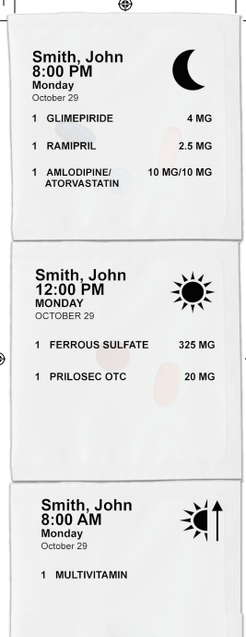
At MedWiz Specialty Pharmacy, we personalize patient care using a patient-centered approach. Our clinical team works directly with patients and their respective providers to develop a tailored, patient-focused healthcare plan that improves patient outcomes, enhances patients' quality of life, and facilitates patient care goal achievement. The clinicians also provide initial and ongoing monitoring, proactive refill management, as well as patient education and counseling to ensure safe and effective use of medications and promote adherence to therapy.
Our pharmacy offers insurance verification, 28-day cycle-fill schedule, and a dedicated team to synchronize medication management and ensure no interruptions in patient therapy. Our unique program enhances patient adherence and compliance by providing patients with a pre-filled MedWiz Specialty Pill Box. This innovative program sorts medications in individual pouches organized by date and time of administration. Pouches are clearly labeled, securely sealed, and optimal for use at home and on the go. This technique helps facilitate medication administration and reduces medication-related errors.
Please send all mediation orders directly to our specialty pharmacy:
E-Scribe: MedWiz Specialty Pharmacy
940 S. Frontage Rd, STE 500,
Woodridge, IL 60157
NCPDP- 1497040
NPI- 1538742622
Fax: 630.580.1720
Phone: 630.580.1700
Sincerely,
The MedWiz Specialty Team

Dear ______________________________,

This letter is to inform you that your patient
Name: ________________________________________
DOB: ________________________________________

Would like all prescriptions sent to MedWiz Specialty Pharmacy:
E-Scribe: MedWiz Specialty Pharmacy
940 S. Frontage Rd, STE 500,
Woodridge, IL 60157
NCPDP- 1497040
NPI- 1538742622
Fax: 630.580.1720
Phone: 630.580.1700

Sincerely,
The MedWiz Specialty Team

